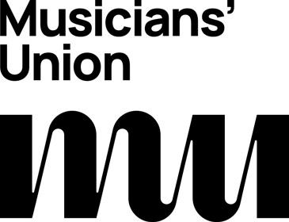
Access Rider
for disabled musicians, performers, artists, composers, and technical staﬀ in venues.
*Please do not share this document without my prior consent
Introduction

My access needs

Emergency information

Further information

